Course: Web Application Development
Lab Instructor: Assoc.Prof.Nguyen Van Sinh
Email: nvsninh@hcmiu.edu.vn

Lab 5 - Database (MySQL), JSP

Content:
- Introduction DBMS - MySQL
- Java Server Pages.
- Connection JSP-MySQL

Duration: 3 hours

Part 1: Introduction Database Management System MySQL
Install (MySQL Version 6, admin tool - use Graphic User Interface). Refer from this site: http://dev.mysql.com/doc/
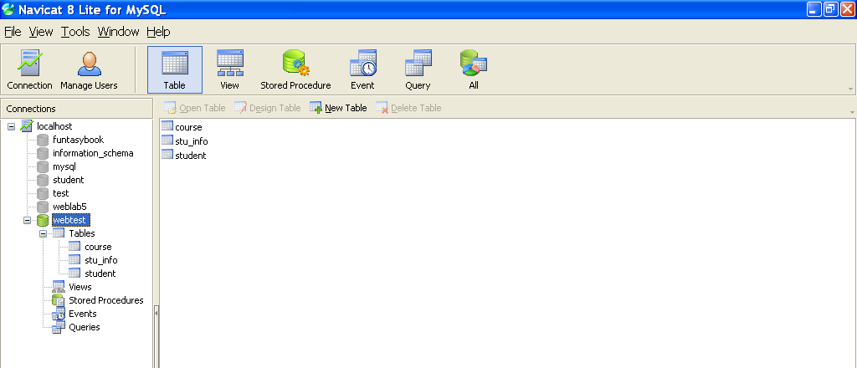
You can use the command line on window to create database for your website
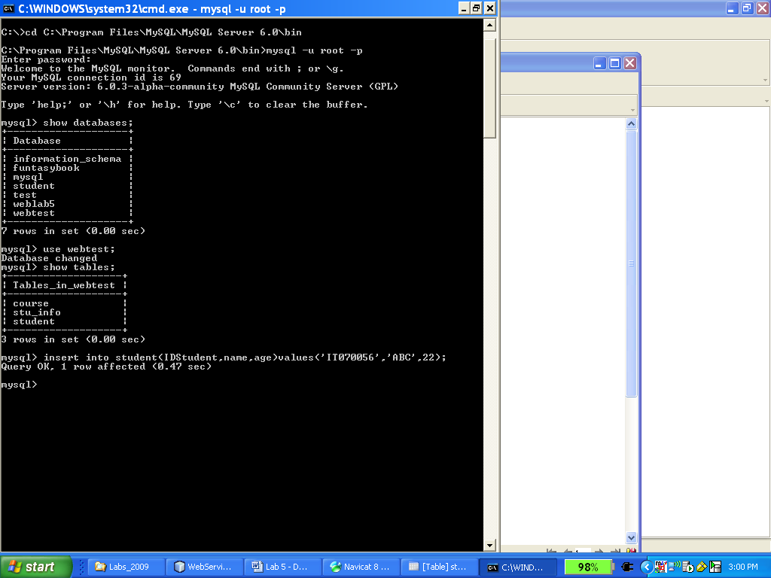
Basic commands on mysql command line:
mysql -u root -p mysql Logon to MySQL
mysqladmin -u root shutdown Shutdow MySQL
show databases; View Databases
show tables; View Tables
select * from tables_name; View content of tables
exit; Exit and close MySQL

Get help from mysql command
help [command] Help for syntax of a command on server side
? Help for syntax of commands on client side

Example: creates a database for registry course

-- --------------------------------------------------------

--
-- Table structure for table 'course'
--

CREATE TABLE IF NOT EXISTS 'course' (
'CourseID' bigint(20) NOT NULL auto_increment,
'CourseName' varchar(255) NOT NULL,
PRIMARY KEY ('CourseID'),
KEY 'Course_CourseID_INDEX' ('CourseID')
) ENGINE=InnoDB DEFAULT CHARSET=utf8 AUTO_INCREMENT=5 ;

-- --------------------------------------------------------

--
-- Table structure for table 'student'
--

CREATE TABLE IF NOT EXISTS 'student' (
'StudentID' int(11) NOT NULL auto_increment,
'StudentName' varchar(255) NOT NULL,
PRIMARY KEY ('StudentID')
) ENGINE=InnoDB DEFAULT CHARSET=utf8 AUTO_INCREMENT=6 ;

-- --------------------------------------------------------

--
-- Table structure for table 'studentcourse'
--

CREATE TABLE IF NOT EXISTS 'studentcourse' (
'StudentID' bigint(20) NOT NULL,
'CourseID' bigint(20) NOT NULL,
PRIMARY KEY ('StudentID','CourseID'),
KEY 'StudentCourse_StudentID_INDEX' ('StudentID'),
KEY 'StudentCourse_CourseID_INDEX' ('CourseID')
) ENGINE=InnoDB DEFAULT CHARSET=utf8;

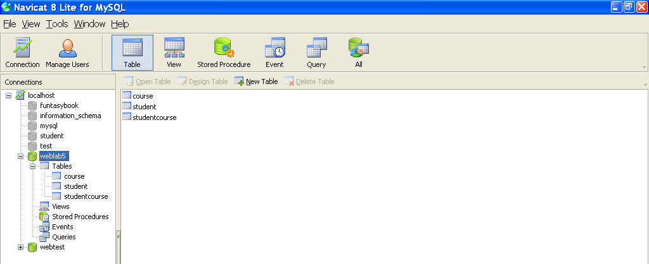

Part 2: Java Server Pages
In this part, you will design many jsp pages. Using java source code, embed to html page. The first page (login.jsp) is to check username and password to login another page.

<%@page contentType="text/html" pageEncoding="UTF-8"%>
<%@page import="java.sql.Statement"%>
<%@page import="java.sql.ResultSet"%>
<%@page import="java.sql.PreparedStatement"%>
<%@page import="java.sql.DriverManager"%>
<%@page import="java.sql.Connection"%>
<html>
<head>
<meta charset="UTF-8">
<title>Login Form</title>
</head>
<body>
<h2>Login Form</h2>
<form method="post" action="Login.jsp">
<label for="username">Username:</label>
<input type="text" id="username" name="username" required><br><br>
<label for="password">Password:</label>
<input type="password" id="password" name="password" required><br><br>
<input type="submit" name="Login" value="Login">
</form>
<%
if (request.getParameter("Login") != null) {
String username = request.getParameter("username");
String password = request.getParameter("password");

Class.forName("com.mysql.jdbc.Driver");
String jdbcUrl = "jdbc:mysql://localhost:8889/weblab5?autoReconnect=true&useSSL=false";
String dbuser = "root";
String dbpassword = "root";

Connection con = DriverManager.getConnection(jdbcUrl, dbuser, dbpassword);

PreparedStatement ps = con.prepareStatement("SELECT * FROM user WHERE username=? AND password=?");
ps.setString(1, username);
ps.setString(2, password);

ResultSet rs = ps.executeQuery();

if (rs.next()) {
out.print("Connect sucess!");
response.sendRedirect("index.html");

} else {
// Invalid credentials, show error message
out.print("Invalid username or password.");
}
}
%>
</body>
</html>

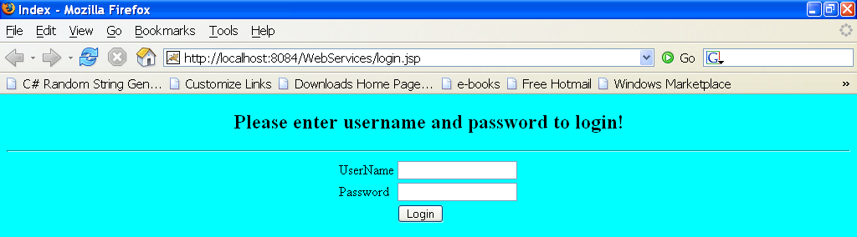

If user input valid username and password, he/she will go to homepage.java, else there is an error message.
In the homepage.jsp of your website, there is also a hit counter for counting visited time of user
Now, create many .jsp pages using data form based on the following source codes:
<%
//Get value from text-box
String value = request.getParameter("name_text_box");
out.print("Hello "+value+"!<br>");

//Get value from radio button
String radioButton = request.getParameter("name_radio_button");
out.print("The gender is: "+radioButton+"<br>");

//Get value from check-box button
String[] courses;
courses = request.getParameterValues("name_check_box");
if (courses != null)
{
out.print("The course: <br>");
for (int i = 0; i < courses.length; i++)
{
out.println (courses[i]+"<br>");
}
} else out.println ("<b>none<b>");
%>

Part 3: Connection JSP - MySQL

Seven steps to connect JSP-DBMS by using JDBC:
Step 1: Load driver using Maven project

First you need to create a maven project in NetBeans: File -> New Project -> Java with Maven -> Web Application
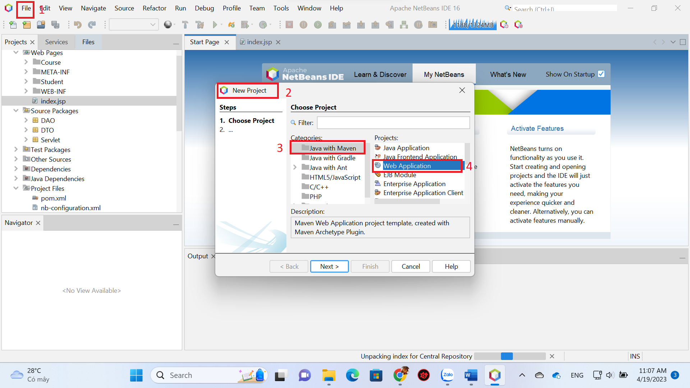

In your Maven project select Project File -> pom.xml. Adding the tag for MySQL connector:

<dependency>
<groupId>mysql</groupId>
<artifactId>mysql-connector-java</artifactId>
<version>8.0.32</version>
</dependency>

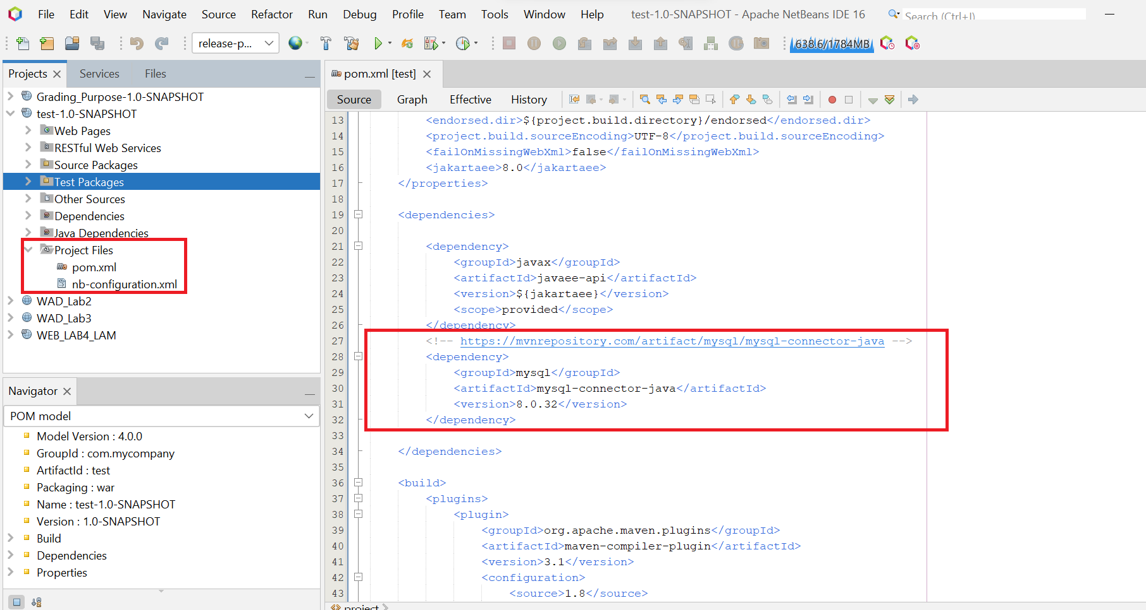

Then, right click on the project -> Reload POM -> Clean and Build. IDE will automatically download MySQL connector library.
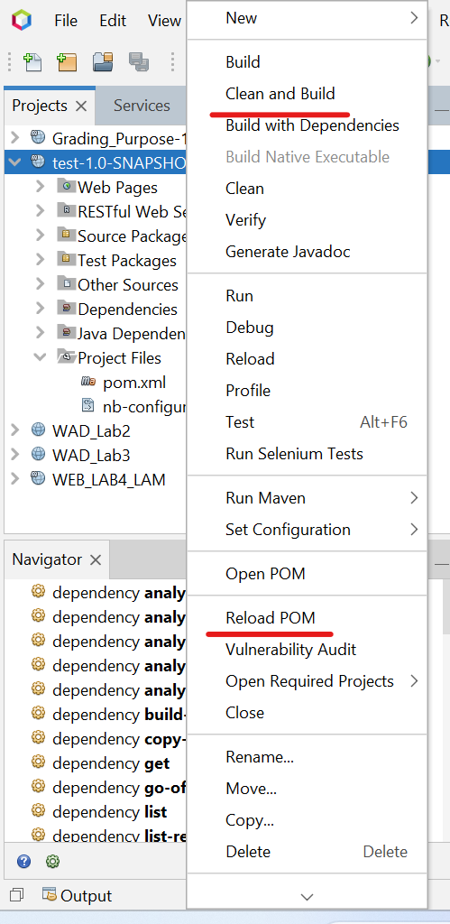
In case you want to know how to get dependency information, go to: https://mvnrepository.com then searching for MySQL:

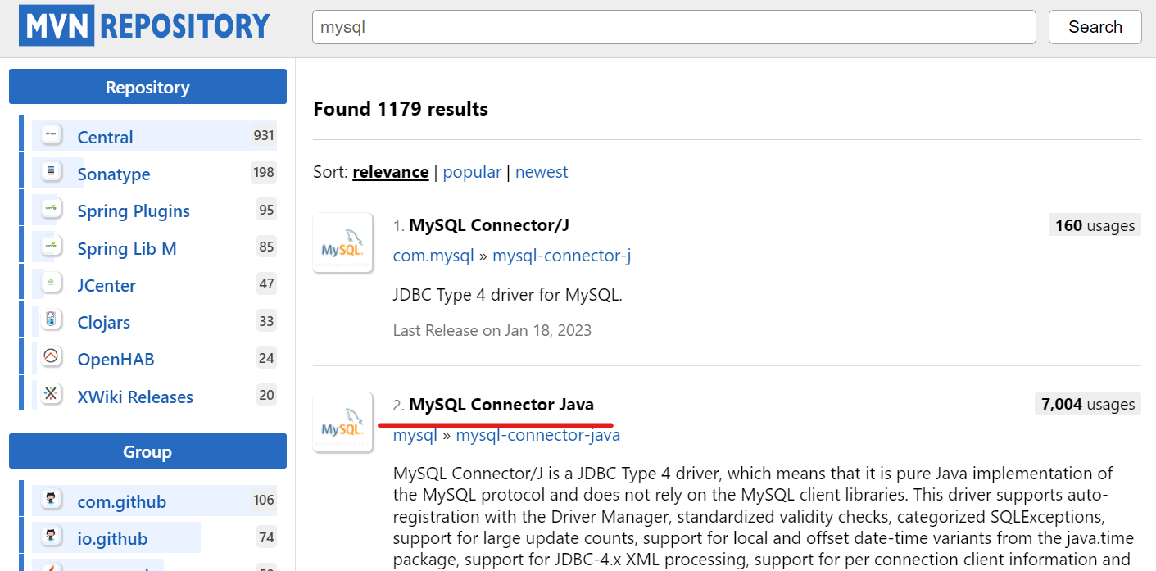

Choose library version:
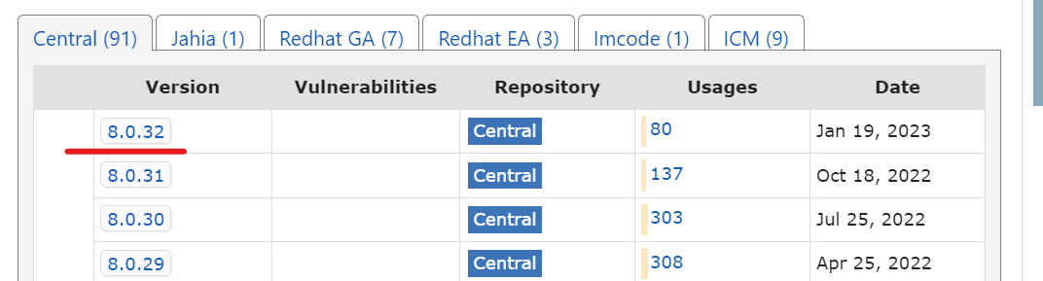

Get library information:
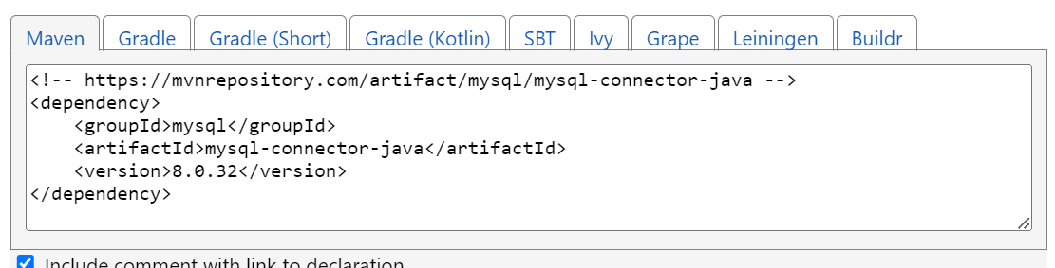
Step 2: Define a connection URL
Step 3: Establish a connection
Step 4: Create a statement object
Step 5: Execute a query
Step 6: Process the results
Step 7: Close the connection

Use the following source below to test your system
--------------------------------------------------------------

<%
String connectionURL="jdbc:mysql://localhost:3306/weblab5?user=root;password="; //step 2
Connection connection = null; //step 3
Statement statement = null; //step 4
ResultSet rs = null;
%>
--------------------------------------------------------------
<%
//Class.forName("org.gjt.mm.mysql.Driver").newInstance();
Class.forName("com.mysql.jdbc.Driver").newInstance(); //step 1
connection = DriverManager.getConnection(connectionURL, "root", "");
statement = connection.createStatement();
rs = statement.executeQuery("SELECT * FROM course"); //step 5

while (rs.next()) {
out.println(rs.getString("CourseID"));
out.println(rs.getString("CourseName")+"<br>");
} //step 6
rs.close(); //step 7
%>

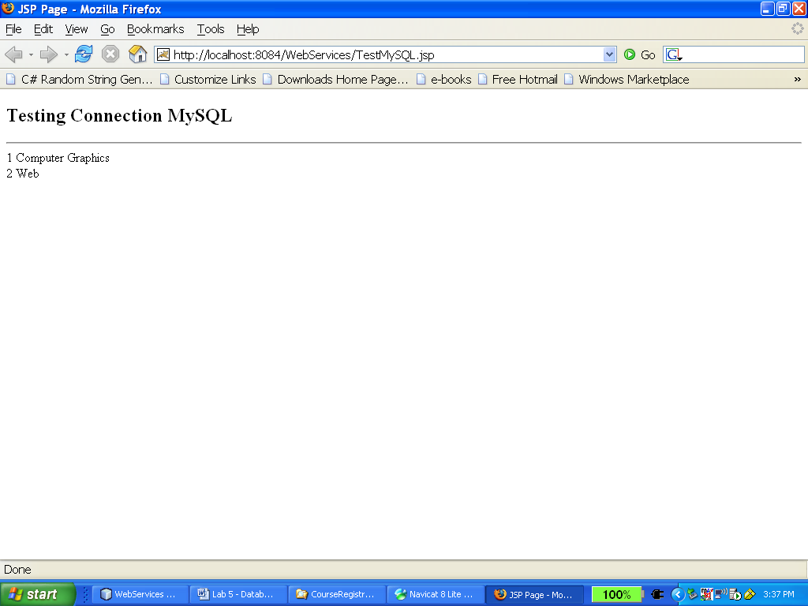
Now go on to develop your project base on the following interactions:

This is the structure of website:
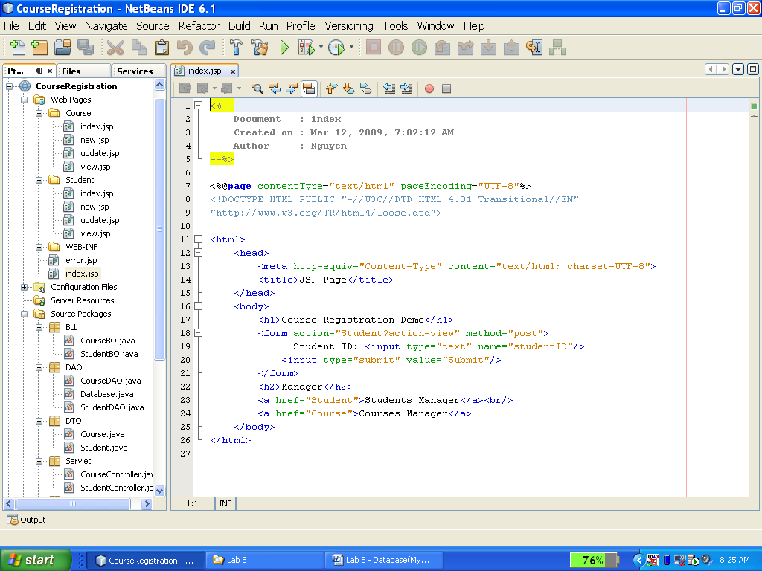

First page: allow to input Student ID and click Submit button to search

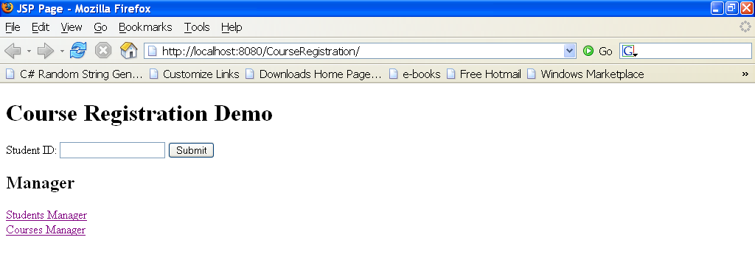
Second page: return information of registry course
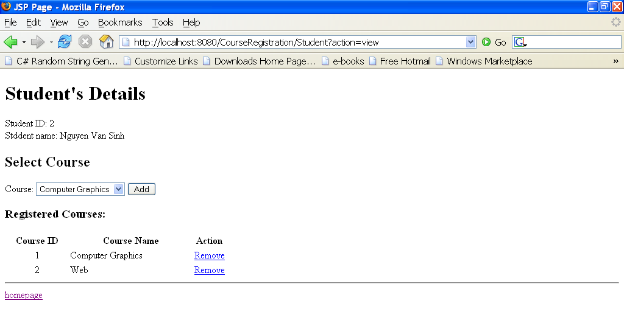

Third page: when click the link “Student Manager”:

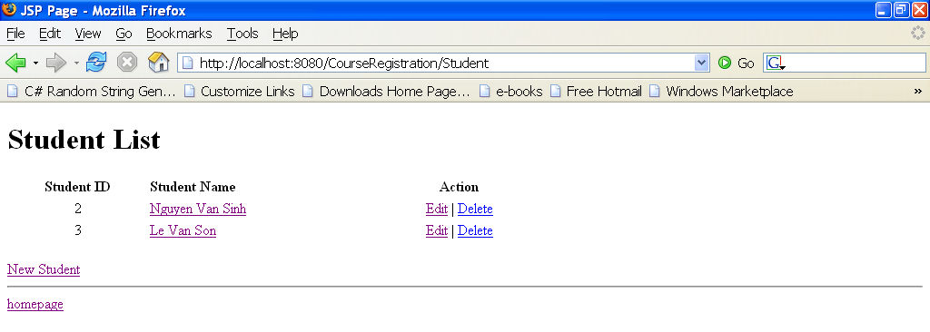

The page 4: when click the link “Course Manager”

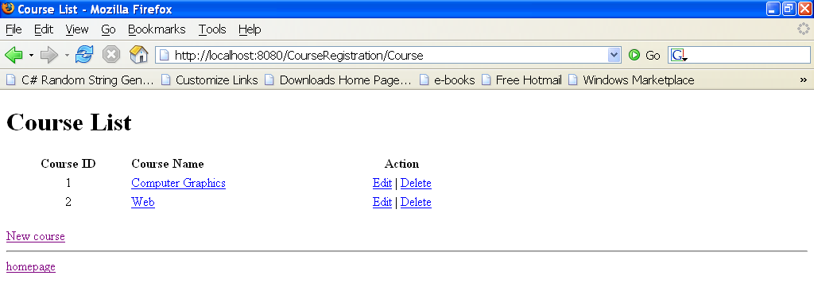
In this page, user can click to “Edit” to modify or click to “Delete” to delete information.

The next page: from the above page, user click to the name of course to see “Course’s Detail”
